Remera Sector Ministry of Education - Pedagogic Training Workshops

Trimester 2 – 10 Suggestions for Improved Teaching Practice

1) EXPLAIN OBJECTIVES BEFORE: Remember to explain your objectives to the
students at the start of each lesson. If necessary, use Kinyarwanda.

2) REVIEW OBJECTIVES AFTER: Remember to review your objectives with the students at the end of each lesson. If necessary, use Kinyarwanda.

3) HELP STUDENTS WITH VOCABULARY: Whatever subject you teach (except Kinyarwanda), make sure the students write down new English vocabulary in the back of their notebooks every lesson (from P2). It is OK for the students to write down translations:

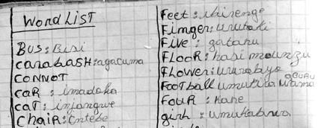

4) USE ENGLISH FIRST: Use English as much as possible:
- to give common instructions or classroom language:
‘open your books’, ‘work in groups’, ‘Who can help him?’ ‘Good!’
- to explain simple / concrete vocabulary (words like: ‘swim’, ‘chair’, ‘happy’)
- to practise English speaking, listening and writing:
‘Tell your partner about your favourite food.’

5) USE KINYARWANDA AS A LEARNING TOOL: It’s OK to use Kinyarwanda in these situations:
- to explain a difficult concept or idea (but also teach the English words)
- to give the instruction for a difficult activity:
‘draw a picture to illustrate the water cycle, but don’t label it yet.’
- to translate difficult / abstract vocabulary (words like: ‘decision’, ‘believe’, ‘worried’)

6) USE LARGE GROUPS FOR CHALLENGING TASKS: Use large groups (4-6) for difficult exercises, long activities, or when the students have to be creative. Never create groups of over 6 students.

7) USE SMALL GROUPS FOR MOST TASKS: Use small groups of 2-3 for most exercises. This way all the students are involved, and no reorganisation of the class is necessary.

8) COMPARE AFTER INDIVIDUAL WORK: Use individual work when you think all the students can do the exercise alone. Always get the students to compare their answers in 2s or 3s after individual work.

9) KEEP ACTIVITIES SIMPLE: Remember that it is not necessary to give a different activity to each group. It is useful to give the same activity to all the groups.

10) EXPERIMENT: We learn from our successes and our mistakes. Keep experimenting with new ideas and activities, and share your success with your colleagues!
Tell me and I forget.
Show me and I remember.
Involve me and I learn.

Numbwira, ndibagirwa Nunyereka, ndibuka
Ndeka nkore, mbitahure
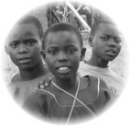

Which teacher do you want to be?

