Workshop on
Child-centred Methodology
Participant’s Handbook
includes resources for the workshop
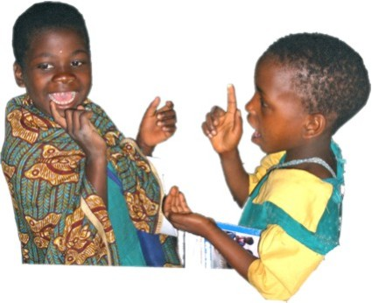
Learners at Kadzuwa FPS, Luchenza Zone, Thyolo District learning the sounds of letters through song in a Chichewa lesson
Workshop on Child-centred Methodology
Participant’s Handbook

Contents
Foreword 4
List of Contributors 5
Suggested Timetable 6
Aim and Objectives of the Workshop 7
Session 2 – Welcome - Resource 1 8
Session 2 – Welcome - Resource 2 9
Session 2 – Welcome - Resource 3 10
Session 3 – How Do Children Learn? - Resource 1 11
Session 3 – How Do Children Learn? - Resource 2 12
Session 3 – How Do Children Learn? - Resource 3 13
Session 3 – How Do Children Learn? - Resource 4 - Bingo 17
Session 3 – How Do Children Learn? - Resource 5 – Running Dictation 18
Session 3 – How Do Children Learn? - Resource 6 – Pelmanism 19
Session 4 – What is Child-centred Learning? Resource 1 20
Session 4 – What is Child-centred Learning? Resource 2 21
Session 4 – What is Child-centred Learning? Resource 3 22
Session 5 – Planning for Child-centred Learning - Resource 1 23
Session 5 – Planning for Child-centred Learning - Resource 2 24
Session 5 – Planning for Child-centred Learning - Resource 3 25
Session 5 – Planning for Child-centred Learning - Resource 4 – Statements 26
Session 5 – Planning for Child-centred Learning - Resource 5 36
Session 6 – Essential Resources for Child-centred Learning in Africa – Resource 1 37
Session 6 – Essential Resources for Child-centred Learning in Africa – Resource 2 38
Session 7: Pocket Board, Resource 1 39
Session 7: Pocket Board, Resource 2 41
Session 8 – The Stimulating Classroom - Resource 1 42
Session 8 – The Stimulating Classroom - Resource 2 43
Session 9 – Classroom Posters - Resource 1 44
Session 9 – Classroom Posters - Resource 2 45
Session 10 – Make and Do – Resource 1 46
Session 10 – Make and Do - Resource 2 47
Session 10 – Make and Do - Resource 3 48
Session 10 – Make and Do – Resource 4 49
Session 11 – Challenges and Solutions - Resource 1 50
Session 11 – Challenges and Solutions - Resource 2 51
Session 11 – Challenges and Solutions - Resource 3 52
Session 12 – Implementation - Resource 1 – For PEAs / Teacher Trainers 53
Session 12 – Implementation - Resource 2 – For Teachers 54
Session 12 – Implementation - Resource 3 – Poster Plan 55
Session 13 – Lesson Preparation for a Child-centred Lesson - Resource 1 56
Session 13 – Lesson Preparation for a Child-centred Lesson - Resource 2 – Lesson Plan 57
Session 16 – Self and Peer-evaluation of Lessons Resource 1 59
Session 17 – Personal Action Plans Resource 1 60
Session 17 – Personal Action Plans Resource 2 61
Session 17 – Personal Action Plans Resource 3 62
Session 18 – Workshop Evaluation - Resource 1 63

Foreword

List of Contributors

List of Contributors to the MOEST 5-day Teacher
Training Workshop on Child-centred Methodology

Paul Chindamba PEA - Zomba Rural – St. Theresa Zone
Mathias January Domasi College of Education
Patrick Kapito Chancellor College
Michael Lwanda Principal Methods Advisor, DIAS
Misheck Munthali Domasi College of Education
Liznet Mwadzaangati Chancellor College
Patrick Themu MOEST - DTED
Gibson Zembeni Malawian Education Consultant (Prof. TALULAR)
Sue Mitchell VSO / MIE
Regina Junio VSO
Charles Nabongo UNICEF Malawi
Panji Chamdimba UNICEF Malawi
Michael Banda UNICEF Malawi
Jason Anderson UNICEF Consultant
A.K.M. Kamaluddin UNICEF Consultant

Suggested Timetable
MOEST Teacher Training Workshop on
Child-centred Methodology
Suggested 5 Day Timetable

 | Day 1 | Day 2 | Day 3 | Day 4 | Day 5
08:00-10:00  (2 hrs) | 1. Registration  (at 9:30am)  Participants arrive and register. Housekeeping and ground rules. | 4. What is child-centred learning?  We learn about how effective learning should build on our learners’ knowledge, skills and interests, and take part in a child-centred lesson. | 8. The stimulating classroom  We learn about stimulating classrooms from other parts of Africa and then create our own stimulating classroom. | 11. Challenges & solutions  We discuss common challenges faced by teachers in the classroom in Malawi and find out about solutions found by other teachers. | 15. Delivery of child-centred lessons  We teach child-centred lessons to children at a local primary school.
Break
10:30 - 12:30  (2 hrs) | 2. Welcome  We participate in a team-building activity to build friendship between the participants. We discuss our expectations for the workshop. | 5. Planning for child-centred learning  We learn more about effective learning. We evaluate lessons from the Teacher’s Guide and personalise them to the learners we teach. | 9. Classroom posters  We learn about what makes a good poster, how to create and use them (both teacher and learners) and also look at stimulating alternatives. | 12. Implementation  Participants reflect on how they will implement what they have learnt & support each other in the process. | 15. Delivery of child-centred lessons continued  16. Self and peer-evaluation  We evaluate how our lessons went, and reflect on what we can learn from this.
Lunch
13:30-15:30  (2 hrs) | 3. How do children learn?  We learn about how young children learn at different ages, and we try out some activities that appeal to many different learning styles. | 6. Essential resources for child-centred learning in Africa  We learn about key TALULAR resources available to us in Malawi and how to use them. | 10. Make and do  We create our own resources for child-centred learning and reflect on how resource creation can help children to develop a range of thinking skills. | 13. Lesson preparation for a child-centred lesson  Working in groups, we prepare our lessons for tomorrow. | 17. Personal action plans  We create targets for personal improvement.  18. Workshop evaluation  We provide feedback on the workshop. Workshop closes.
Break
16:00-17:30  (1.5 hrs) | 3. How do children learn?  (continued) | 7. Pocket boards  We create an important resource to help us teach more effectively. | 10. Make and do  (continued) | 14. Resource preparation for a child-centred lesson  We prepare effective resources for our lessons.

Aim and Objectives of the Workshop

Aim and Objectives of the 5-day Teacher Training Workshop on Child-centred Methodology
Aim
To improve the quality of teaching and learning in Malawian primary classrooms through strengthening the capacity of the Ministry of Education, teacher training colleges, the curriculum development department and selected primary schools to promote effective child-centred learning with the support and assistance of UNICEF Malawi and VSO Malawi.
Objectives
By the end of the workshop participants will…
- have a sound understanding of the concepts and practices of child-centred, interactive methodology in teaching and learning processes
- have a better understanding of problem solving techniques and increased awareness of active learning opportunities
- be able to use a simple planning system to support a child friendly curriculum
- be able to design and make a range of high quality resources and teaching aids from locally-available, low cost materials to support child-centred learning
- have prepared, taught and evaluated a child-friendly lesson (in a Malawian primary school)
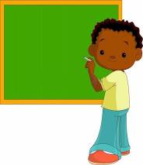
- have begun planning to implement effective child-centred learning in the Malawian education system

Session 2 – Welcome - Resource 1

Teamwork challenge – Make a newspaper tower

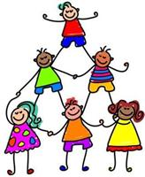
The Challenge:
Work in groups of four. Your aim is to build a free standing tower from a single newspaper only. You cannot use any other materials at all, only the newspaper. The highest tower at the end of 20 minutes will win. However, 2 members of your group will have disabilities:
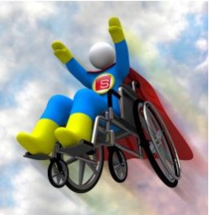
Member A) Your disability is that you cannot speak.
Member B) Your disability is that you can only use one hand.

Decide who these members are now.

A group of ‘observers’ will observe the activity.

Session 2 – Welcome - Resource 2

Observer Role for the Teamwork Challenge

You are one of the observers. Your aim is to observe the groups, make sure that they don’t break any of the rules of the challenge and also notice the different roles everybody adopts. At the end, you will provide feedback to the groups you observe. You may be observing one or two groups. Complete these tasks while you observe:

A) Group Roles
Often different group members adopt different roles. Although there are only 4 in the group, you may notice that some of them adopt these roles. If they do, write their names on the right:
- The Controller – thinks s/he should lead the group, and (sometimes) that the others are useless. _____________
- The Passenger – tries to do as little as possible. _____________
- The Criticiser – criticises other people’s ideas, but often doesn’t make any useful suggestions. _____________
- The Talker – talks and talks, but may not actually get anything done. _____________
- The Doer – gets the job done; there are often several in a group, and they work well together. _____________
- The Mediator – tries to maintain good relationships between the group members. _____________
- The Servant – is happy to do anything somebody else tells them to, but doesn’t like to take responsibility. _________

B) Disabilities
Notice how each group involves the members with disabilities. Do they make them feel welcome? Do they try to consult them as much as possible? Do they order them around like they are children? Make notes:

Session 2 – Welcome - Resource 3
Teamwork Challenge - Final Group Discussion
Well done! Now it’s time to talk about how you did, and to learn from your
successes and errors.

General Discussion – 5 minutes
How well did the group work together?
What problems occurred and why? How were these problems solved?
Which was more important in your opinion? Why?
 making a good tower  working well as a team  involving the team members with disabilities

Group Roles – 10 minutes
Often different group members adopt different roles. Do you recognise anybody in these descriptions?
- The Controller – believes s/he should lead the group, and (sometimes) that the others are useless.
- The Passenger – tries to do as little as possible.
- The Criticiser – criticises other people’s ideas, but often doesn’t make any useful suggestions.
- The Talker – talks and talks, but may not actually get anything done.
- The Doer – gets the job done; there are often several in a group, and they work well together.
- The Mediator – tries to maintain good relationships between the group members.
- The Servant – is happy to do anything somebody else tells them to, but doesn’t like to take responsibility.

Learning Points -5 minutes
As a group, think of 2 or 3 things that you learned from doing this activity. Write them in this box:

Application – 5 minutes
What skills would learners in Standard 4 learn from doing this activity?
Would you be happy to try it with them?

Session 3 – How Do Children Learn? - Resource 1
How Children Learn
CHARACTERISTICS OF CHILDREN AT DIFFERENT AGE GROUPS
Infant Section (approximate ages 5 to 7)
- Most of these infant learners learn best with concrete experiences and immediate goals.
- Infant learners like to name objects, define words, and learn about things in their own world.

- They also have a vivid imagination and respond well to stories of fantasy.
- They need to know how to feel about something in order to learn it well.
- Infant learners learn through oral language; they are capable of developing good oral skills, pronunciation, and intonation when they have a good model.
- They learn well, especially in the first year of schooling, through dramatic play, role-play, and use of story form with a strong beginning, middle and end.
- They need to have a great variety of activities, because of their short attention span
- The teacher must keep in mind that infants tire easily.
- They are still unskilled with fine motor skills e.g. holding writing materials.
- Teachers of infant learners must give structured and specific instructions and build regular routines and patterns into the daily lesson plan.

Junior Section (approximate ages 8 to 10)
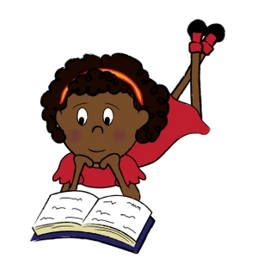
- They are very open to new situations and experiences.
- They are interested in the world around them.
- They begin to understand cause and effect.
- They work well in groups.
- They can begin a more systematic approach to language learning, but they continue to need first-hand, concrete experiences as a starting point.
- They may not like to work with partner members of the opposite sex.
- They continue to benefit from experiences with imagination and fantasy.
- They are very interested in real-life heroes and heroines.

Senior Section (approximate ages 11 to 14)
- At this stage, learners are undergoing more dramatic developmental changes than experienced at any other time in life.
- They begin to challenge what they are taught.
- Relationships within their peer group (friends) become the most important thing.
- They need the opportunity for broad exploration, as well as an introduction to the demands of academic disciplines.
- They can understand abstract concepts.
- Learners will respond well to opportunities to learn about subjects that interest them in great detail.
- Heroic figures with qualities that overcome danger are especially good choices for role models, and at this age, learners need learning experiences with a strong emotional message.
- Learners show high interest in the unusual and the extremes in the real world.
- Teachers need to encourage positive relationships and a positive self-image in the learners.

Key questions: How true is this for children in Malawi? Do you disagree with any of the facts?

Text adapted from Curtain, Pesola & Dahlberg – Languages and children: Making the Match (1994, Longman)

Session 3 – How Do Children Learn? - Resource 2
How Children Learn
Discussion 1
Do you agree or disagree?
1) Children learn differently in infant, junior and senior sections of primary school.
2) Children in a class learn in different ways.
3) It’s impossible for a teacher with a large class to provide for the needs of all the learners.

Discussion 2
Discuss these questions for all 3 activities:
1) Which age groups can do the activity?
2) How could you adapt the activity for different subjects (e.g. maths, English, Chichewa, science, etc.)?
3) How was the learning made interesting?

Discussion 3
Which of these learner types would learn well from each of the activities?
- visual learners (they like to see and remember things in space)
- social learners (they like to learn in groups and communicate)
- kinaesthetic learners (they like to move about and touch things)
- auditory learners (they like to hear things, to say things and to sing songs)
- logical / mathematical learners (they like to categorise things and find solutions to problems)

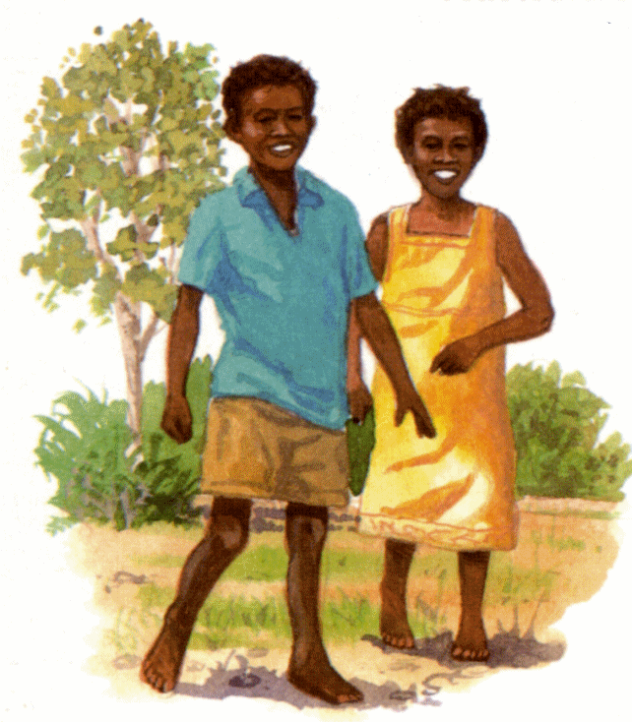
Optional:
If you have children, which of the activities do you
think they would like? Why?

Session 3 – How Do Children Learn? - Resource 3
Activity: Participants categorise the cards to the age group to which they think the card applies: 5-7 8-10 11-14 (Answers: first 7 are for 11-14. Next 7 are for 8-10. Last are for 5-7), but some do cross over. (cut up the cards)
Relationships within their peer group (friends) becomes the most important thing. | They can understand abstract concepts.
They begin to challenge what they are taught. | They can be motivated by external factors (extrinsic motivation).
They enjoy learning about extreme and unusual things. | They are extremely interested in a small number of subjects.
They are very idealistic.
They are interested in the world around them. | They are very open to new situations and experiences.
They work well in groups. | They may not like to work with partner members of opposite sex.
They are very interested in real life heroes and heroines. | They are beginning to understand cause and effect.
They enjoy learning for its own sake (intrinsic motivation).
They learn best with concrete experiences and immediate goals. | They have a vivid imagination.
They learn through oral language; and develop good pronunciation when they have a good model. | Because of their short attention spans, they need to have a great variety of activities.
They tire easily. | They are still rather unskilled with small-muscle tasks.
They need and enjoy regular routines and patterns every day.

Age group 1 – 5-7 years

Age group 2 – 8-10 years

Age group 3 – 11-14 years


Session 3 – How Do Children Learn? - Resource 4 - Bingo
Learners work in small groups. Each group receives a card and writes six numbers between 1 and 10 onto their card. The facilitator reads out various addition and/or subtract sums. If the participant has the answer on their card they cross it out. The participant who crosses out all the numbers shouts ‘bingo!’ and wins. Learners can also do it in their exercise books.




Session 3 – How Do Children Learn? - Resource 5 – Running Dictation
Cut up into 3 sections along the dotted lines and stick on classroom walls in different places. Learners work in pairs, where one is a secretary and the other is a runner who runs to read a statement, runs back to secretary to dictate for him/her to write down (no shouting at distance). The first pair to write down all 12 sentences are the winners. This can be done with any text in mother tongue or English, and can be used to make an activity fun even if you only have one copy of the Pupil’s Book. Do it outside if you have a big class!

- Nsima imapatsa mphamvu

- Tilime chimanga chambiri kuti tizikhala ndi chakudya

- Ana amakonda masewero olimibitsa thupi

- Ndibwino kupita kuchipatala mukadwala



- Munthu amene ali ndi edzi amadwalanso matenda ena.

- Pamsewu pamayenda zinthu zambiri

- Kuchipatala kuli malangizo afunikira

- Chaka chamawa tidzabzala mitengo ina yambiri chifukwa imasunga nthaka.



- Ukhondo umatithandiza kupewa matenda

- Sukulu yathu ili ndi zimbudzi zaukhondo.

- M’dziko la Malawi muli ulimi wosiyanasiyana umene umathandiza anthu kupeza chuma

- Munthu amakhala ndi thanzi labwino akamwa mkaka nthawi ndi nthawi

Session 3 – How Do Children Learn? - Resource 6 – Pelmanism
Cut out the cards below and glue onto card (or just write the words on cards). Create one set of cards per group of 8-10 learners. Spread the cards out face down on the floor randomly. Learners work in pairs. Each pair turns over two cards. If the past and infinitive are the same verb, they keep the cards. If not, they put the cards back exactly where they found them, so that everybody begins to remember where the different cards are located. The team with the most cards at the end are the winners.


go | went | write | wrote
do | did | see | saw
say | said | make | made
run | ran | have | had

Session 4 – What is Child-centred Learning? Resource 1
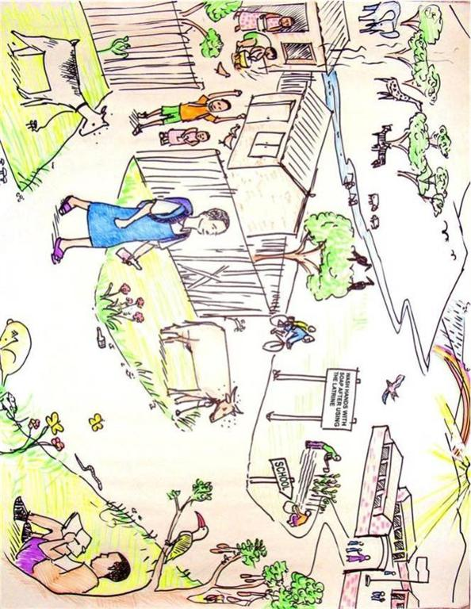

Session 4 – What is Child-centred Learning? Resource 2

Think of a simile or metaphor to describe the relationship between a child
as a learner and the teacher. The pictures may give you ideas.

“A child to a teacher is like...”
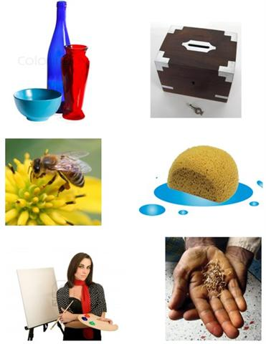

Session 4 – What is Child-centred Learning? Resource 3
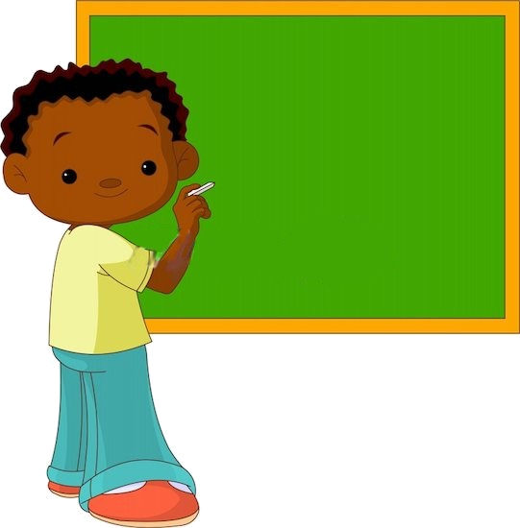
Child-centred learning in Malawi
Make notes on your definition of child-centred learning here. You can change them / add to them as the workshop continues:

Session 5 – Planning for Child-centred Learning - Resource 1
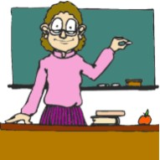
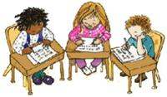
Child-centred or not?
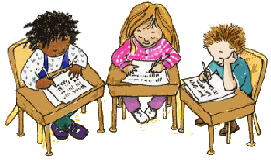

Discuss the questions in the centre column. Make notes on the answers for a non-child centred class (on the left) and for a ‘child-centred’ class (on the right).

Not child-centredChild-centred

The teacher is the source of knowledge, and his / her role is to transmit that knowledge to the learners. | A) What is the role of the teacher? | The teacher is a facilitator of learning. She / he helps the learners to learn.
 | B) How does the learning relate to the children’s world?
 | C) What type of activities do the learners do?
 | D) How do the learners interact with each other?
 | E) How does the teacher respond to differences in ability or learning style between learners?
 | F) What is the curriculum like?
 | G) How is learning assessed?

Session 5 – Planning for Child-centred Learning - Resource 2
Child-centred or not?
The table has been completed with some of the most important differences. There are many other differences you might have that are also correct.

Not child-centred Child-centred learning

Traditional ‘teacher-centred’ teaching Child-centred learning
The teacher is the source of knowledge, and his / her role is to transmit that knowledge to the learners. | A) What is the role of the teacher? | The teacher is a facilitator of learning. She / he helps the learners to learn.
The teacher assumes that the learners are ‘empty cups’ that need to be filled up with knowledge. The teacher may not try to relate this knowledge to the children’s world. | B) How does the learning relate to the children’s world? | The learning starts with what the children already know and builds on this. The teacher brings real things to class (e.g. flower, mosquito net) and uses examples from the local environment (e.g. a lake, shop, or vehicle that they all know).
Learners listen, repeat and memorise facts. They answer the teacher’s questions and never ask questions themselves. | C) What type of activities do the learners do? | The learners experiment, explore, create, evaluate and analyse. Activities are often practical. Children learn through play and song and enjoyment. They are encouraged to ask questions.
Each learner interacts only with the teacher. Any exercises or activities are done individually. If they interact together, they are punished. | D) How do the learners interact with each other? | They often work together, doing activities in pairs and small groups, sharing ideas and discussing answers.
The teacher often focuses on the stronger learners, who sit near the front and raise their hands first. Weak learners are often neglected. The teacher may also depend on one activity type that doesn’t cater for different learning styles. | E) How does the teacher respond to differences in ability or learning style between learners? | The teacher understands that we all learn differently and includes a variety of activity types in the lesson. She/he also incorporates ‘differentiation’ into the lesson by allowing opportunities for both stronger and weaker learners to keep learning.
It is a body of knowledge that is transmitted to the learners. It is transmitted in the same way to all classes everywhere in the country. | F) What is the curriculum like? | It is relevant to the children and their world, and takes account of their needs at every age. It emphasises a range of skills, such as social skills, fine motor skills, study skills, etc. and doesn’t just focus on knowledge. Teachers can adapt it to the learners’ needs and the local situation.
Through examinations with right / wrong answers. Questions and examples are often abstract and not directly relevant to the real world or the learners’ needs and interests. | G) How is learning assessed? | Through a range of assessment means, including continuous assessment, examinations and project work. As well as answering right / wrong questions, learners are required to evaluate, analyse, express opinions, compare things and apply their knowledge to real world situations.

Session 5 – Planning for Child-centred Learning - Resource 3
“What did you do at school today?”

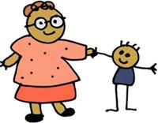

Look at the statements below. Describe why they are child-centred. Use the questions on Resource 1 to help you. For example:
“Number 1 is child-centred because it relates to the child’s world. It also involves pairwork and creativity.”

1) “Today in English, we did a speaking activity working in pairs. We had to role play a conversation in a shop. I was the customer first, then the shop-keeper.”
2) “Today I gave a presentation on my favourite book to the other students. The teacher gave me a mark for my public speaking skills.”
3) “Today we learnt about evaporation and condensation and their role in the water cycle by boiling a pan of water on a fire and seeing how the water steams up a mirror held above a fire.”
4) “Today we learnt why there are often clouds above Mount Zomba in the afternoon, and why the trees grow so well there. We need to protect the trees or the river in our village may dry up.”
5) “Today we read about two different types of tree. The teacher asked us to find 5 differences between how the trees affect the environment, and then we had to decide which one was better for the farmers in Malawi and present our reasons why.”
6) “Today the teacher asked us which is bigger – the door or the window? I said the door, but then the teacher got us to measure the length and the width with our rulers, and then to multiply them together. In fact the window is bigger – 2.4m².”
7) “Today we played a spelling game in the playground. The teacher put the letters of the alphabet on the ground and we had to run and collect the letters to spell different words. My team did very well. We spelt 3 words correctly!”
8) “Today in English we learned the names of different animals. We said the names, wrote them down, drew pictures, pretended to be the animals and even sang a song. I liked the drawing best, but Jane preferred the song!”
Session 5 – Planning for Child-centred Learning - Resource 4 – Statements
1) “Today in English, we did a speaking activity working in pairs. We had to role play a conversation in a shop. I was the customer first, then the shop-keeper, just like father!”

2) “Today I gave a presentation on my favourite book to the other students. The teacher gave me a mark for my public speaking skills.”

3) “Today we learnt about evaporation and condensation and their role in the water cycle by boiling a pan of water on a fire and seeing how the water steams up a mirror held above a fire.”

4) “Today we learnt why there are often clouds above Mount Zomba in the afternoon, and why the trees grow so well there. We need to protect the trees or the river in our village may dry up.”

5) “Today we read about two different types of tree. The teacher asked us to find 5 differences between how the trees affect the environment, and then we had to decide which one was better for the farmers in Malawi and present our reasons why.”

6) “Today the teacher asked us which is bigger – the door or the window? I said the door, but then the teacher got us to measure the length and the width with our rulers, and then to multiply them together. In fact the window is bigger – 2.4m².”

7) “Today we played a spelling game in the playground. The teacher put the letters of the alphabet on the ground and we had to run and collect the letters to spell different words. My team did very well. We spelt 3 words correctly!”

8) “Today in English we learned the names of different animals. We said the names, wrote them down, drew pictures, pretended to be the animals and even sang a song. I liked the drawing best, but Jane preferred the song!”

9) “Today the teacher taught us lots of different words. We repeated each one many times, and then individual students said the words, and then we repeated them again, for example… Oh, I’ve forgotten the words already!”

10) “Today the teacher made us copy a picture from the board into our books and then we copied a description, which I didn’t understand. The thing in the picture was called a ‘cell’. What’s a cell? Is it something good to eat?”

Session 5 – Planning for Child-centred Learning - Resource 5
Planning for Child-centred Learning
Choose a lesson or unit from one of your Teacher’s Guides. Look at the suggested activities. Discuss the following questions and make notes:
1) Does the learning relate to the children’s world?

2) Is there a good variety of activity types? (e.g. experimenting, exploring, creating, analysing, evaluating)

3) Is there a variety of ‘interactions’? (e.g. pairwork, groupwork, individual work, question and answer - all are important)

4) Is there an opportunity for the learners to learn something new? (this is important in all lessons)

5) Is there an opportunity for enjoyment (e.g. a game or a song)?

If you answer ‘Yes’ to all these questions, it is probably an effective child-centred lesson. If you answer ‘No’ think of how the lesson can be changed / improved.

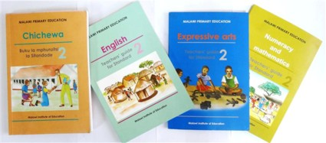

Session 6 – Essential Resources for Child-centred Learning in Africa – Resource 1
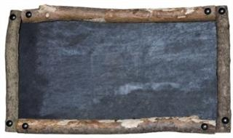

Teaching Resources
in Malawi

Complete the columns of the table. Start with the words in the box, and then think of more. Remember to be creative!

blackboard chalk textbooks posters desks

Teaching resources that all teachers in Malawi have | Teaching resources that most teachers in Malawi have | Teaching resources that some teachers in Malawi have | Teaching resources that no teachers in Malawi have
Session 6 – Essential Resources for Child-centred Learning in Africa – Resource 2
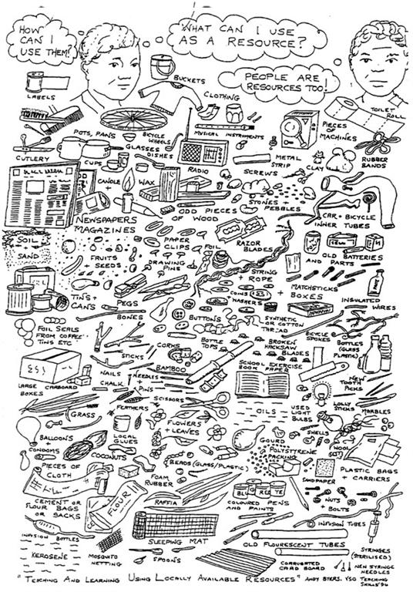
Session 7: Pocket Board, Resource 1

Simple guidelines of how to make a pocket board

Type of cloth
Any inexpensive fabric could be used; preferably cotton, durable/washable. It could be white or off white in colour

Measurements of the cloth
The cloth for making a pocket board measures 1.5m in width and 3.5m in lengths. See the illustration below.

1.5 m

3.5 m

Other Specifications and uses of a pocket board
- Can accommodate ‘pocket cards’ measuring 12cm width by 14cm long
- Stitch the pockets in such a way that it is easy to insert and remove the cards
- It is easy to make
- It can be used to teach many subject concepts
- Uses flash cards with words or pictures on them
- Can have over 200 pockets

Simple guidelines on how to make a pocket board
- Measure 20cm from the top and mark with a straight line
- Make subsequent stripes measuring 8cm and 12cm respectively. Use illustration below as a guide:

20 cm

8 cm

12 cm

8 cm

12 cm

Etc. Repeat pattern

- When all the 8cm and 12cm stripes are made and completed …
- Make the folds by pulling the 8cm strips over 12cm strips as follows:

12 cm

-------------------------------------------------------------------------------------------------------
8 cm

-------------------------------------------------------------------------------------------------------
12 cm cm

8 cm

Etc. repeat pattern

- Once all the horizontal 8cm over 12cm folds are completed, measure vertical lines by first measuring 5cm from the sides followed by 12cm lines. See below:

5 cm | 12 cm | 12 cm | 12 cm | 12 cm

- At this stage, your pocket board is ready for stitching up to make it ready for use in your class.
- At the top or bottom, you attach strings which you can use to hang the pocket board in your class when teaching.

Can’t afford the fabric? Here’s an idea:
Pocketboards can also be made from old rice sacks with rows of fabric stitched horizontally across the sack.

Session 7: Pocket Board, Resource 2
Teachers making a pocketboard together in Rwanda

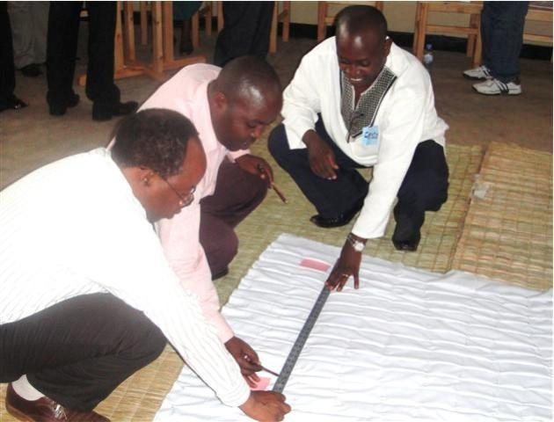

A pocket board being used by learners in Kenya

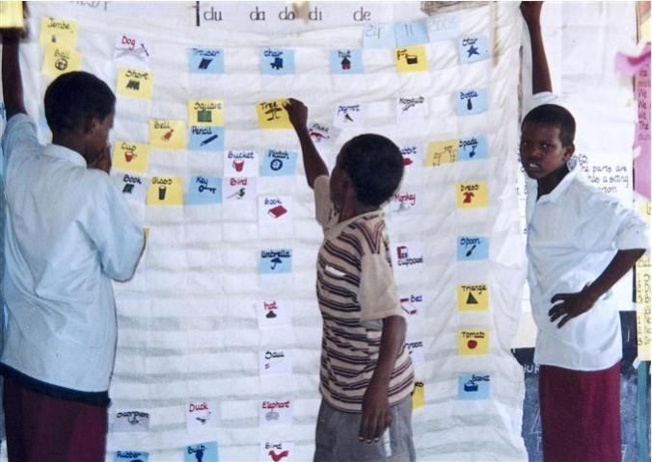

Session 8 – The Stimulating Classroom - Resource 1
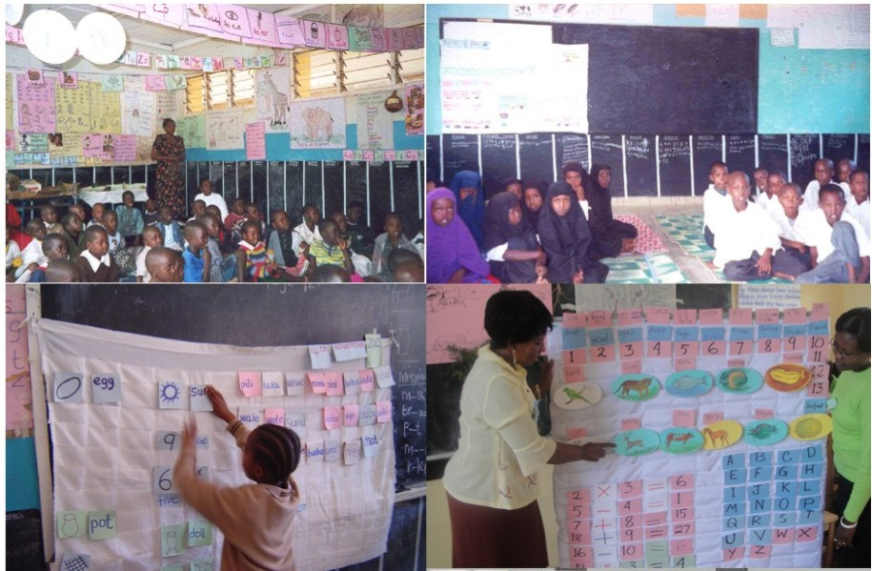

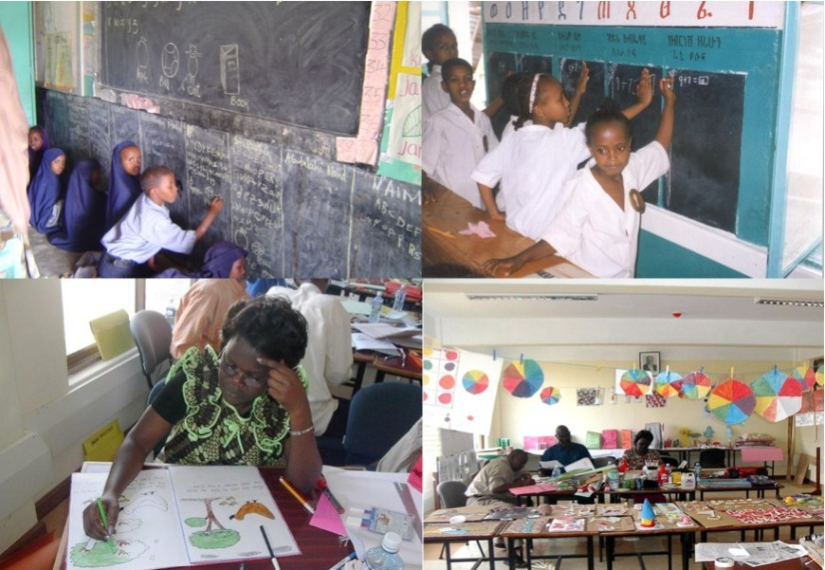
Stimulating Classrooms, Pocketboards, Wall Boards and preparation of materials

Session 8 – The Stimulating Classroom - Resource 2
The Stimulating Classroom
A stimulating classroom is prepared by a trained teacher with the help of other teachers and learners. Generally it consists of a pocket board with word cards, picture cards, numerical cards, walls painted with locally prepared blackboard paint for learners to write on (see below), above which the upper walls are covered with alphabets, numerals and math signs; cut-out images and illustrated stories. There are also lots of relevant low/no-cost teaching learning materials displayed in the learning corners for use by the learners. Optimum use of local resources is encouraged.
Pocket board
The pocket board is a low-cost, useful tool. It is made of an inexpensive cotton fabric measuring 3.5m long and 1.5m wide. It has over 200 pockets measuring 12 cm x 14 cm. The pocket boards with flash cards and pictures or words can be used in hundreds of different ways to teach maths, science and language in all standards, and an effective tool for testing learners. The pocket board is convenient in teaching as it can be used anywhere (in or out of class), is portable, easy to make and promotes teacher learner interaction in classes. The pocket board can also be made from paper, cardboard, rice sacks, mats or any sheets of strong materials.
Wall chalkboards
Wall chalkboards are considered an equally innovative and useful tool by teachers. It is usually prepared by a local paint made from mixing charcoal dust and a dry gum from acacia trees found in many African countries (in Kenya it is called ‘malmal’). The dust is then mixed with either water or paraffin for painting the walls of the classroom especially for standards 1 to 4. Blackboard paint can also be used. It is painted around the walls of the room from the floor to approximately 1m height. Each child is given 30 cm width of the wall and some chalk to write on whenever writing or drawing practice are needed. You can write their name at the top of their space. If you have a lot of children, 30cm can be given to each pair of learners. The wall board helps teachers to monitor individual learner’s progress and to identify weak ones who may require personalized attention and help.
Other Teaching / Learning resources
In addition to the above, a number of high quality teaching learning materials are prepared by the trained teachers from low/no-cost materials that are locally available such as twigs, stones, bottle tops, newspapers, boxes, tin cans, flowers, leaves, cheap and easily obtained materials to make flash cards (e.g. cardboard), big books, charts (e.g. used rice sacks), and various re-usable models and devices (e.g. abacus using bottle tops and / or clay; place value boxes using wood) for learning. These teaching learning materials are kept in the learning corner in the stimulating classrooms for use by the learners.

Session 9 – Classroom Posters - Resource 1

Creating and using classroom posters
Features of Good Posters
- Posters should include a title, clear labels, well drawn features, a variety of colours, carefully used space (not too crowded or heavy on one side), and with features large enough to see from the back of a class
- Posters should also show creative use of different resources/materials.
- Posters should inspire learners’ curiosity and motivation to learn
- Good posters remind and provide important information that aids memory recall
- Good posters emphasize key contents, engage learners and enhance understanding of the lesson
- Good posters create a stimulating classroom environment

- Good posters are re-used often (e.g. revision, multiple subjects, a variety of lessons)
The Benefits of Creating Classroom Posters with Learners

Children can be involved in creating classroom posters, even at very young ages. Learners like to see their own work displayed and class-made posters help learners develop a sense of belonging to the classroom. After creating the posters children can give presentations on them. After the posters have been created, teachers may still use them to present new concepts, display them on the wall to remind and provide information (this helps imprint information on our minds for years to come) and inspire and influence learners’ attitudes and behaviours.

- Learners have created them so they should understand them
- Learners benefit from practising fine motor and perceptual skills (drawing, colouring, organizing a pictorial space)
- Learners benefit from practising social skills (choosing and sharing roles and responsibilities, making decisions together, compromising, etc.)
- Learners draw on a range of cognitive skills (remembering, understanding, applying, analyzing, evaluating and creating - the 6 levels of Bloom’s Taxonomy)
- Teachers and trainee teachers can also benefit from learning how to make posters from textbooks - very useful if they do not have enough textbooks for all learners, and also good if children are very young
Session 9 – Classroom Posters - Resource 2
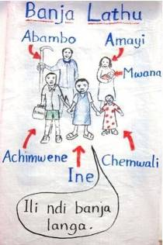
Alternative Ideas for Creating Posters
The poster on the left was created by a teacher on a rice sack with marker pens. The poster below was created using locally available resources (e.g. recycled paper, empty water bottle, marker pens, recycled board/carton).

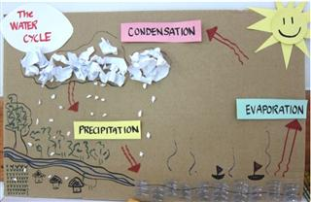

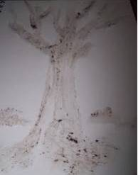
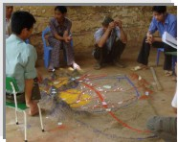
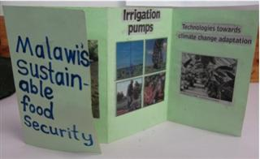
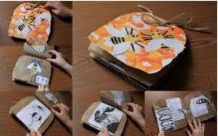
These photos show how soil, sand and stones may be used for creating posters. A village map created by middle school learners using soil, sand and rocks to show topography (mountains, hills, rivers, etc.). The poster beside it shows how kids can use soil as medium for painting.
The photos above show how teachers can make use of other resources, and turn posters into more interactive learning materials (poster book, zig-zag book, collage, mini-diorama, graffiti wall) where children can explore and express their creativity.

Session 10 – Make and Do – Resource 1
How much fun can we have with a piece of paper?

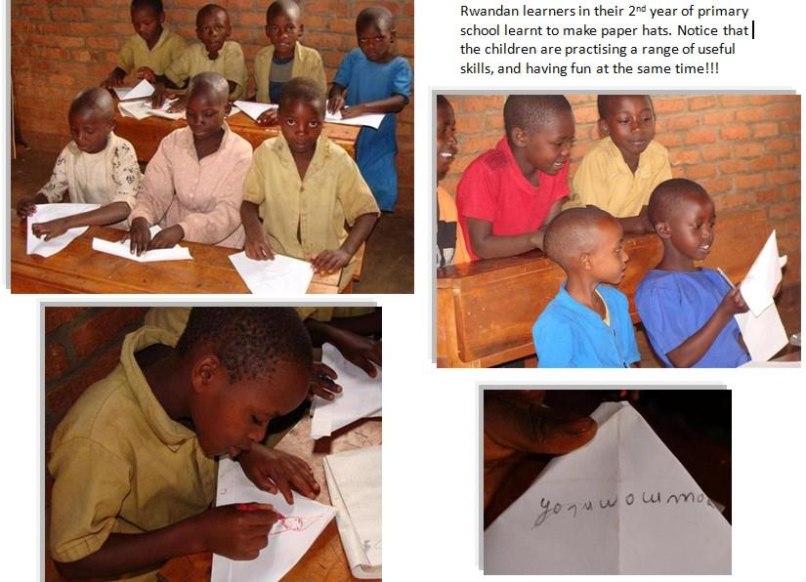
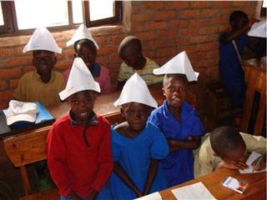
LOW-COST LEARNING MATERIALS
Making teaching-learning materials from low-cost materials was not new to many teachers who apparently learned this in their teacher training institutes. However, they never had considered it useful practice in the real classroom. They did not realize the potential applications until they were introduced to the requirements of child-friendly school models.
Source: Child and Learning-Friendly Environment in Primary Schools: A documentation of the process, UNICEF Ethiopia, 2002.

Session 10 – Make and Do - Resource 2
How simple resources make learning fun and interactive?
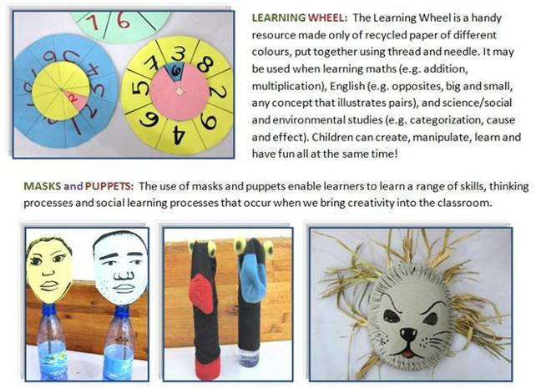

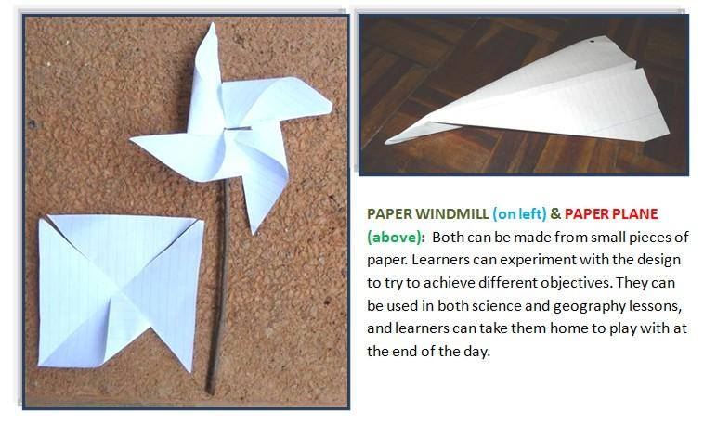

Session 10 – Make and Do - Resource 3
How to make the resources

How to Make a Learning Wheel

You need: 2 small circles (5cm diameter) and one large one (10 cm diameter) of card (or thick paper), ideally of different colours, a little thread or a thorn to attach them together
- Draw straight lines across the circles to divide them into equal portions (i.e. 4, 6 or 8).
- Write different information (e.g. numbers, letters, see Ideas below) on the portions. Leave one of the small circles blank. This blank circle is called the indicator wheel.
- Cut out one of its portions of the indicator wheel.
- Stitch or pin all the three circles together (it’s best to use a needle and thread) with the indicator wheel on top, the other small circle next and the big circle on the bottom.
- The 3 circles should rotate separately so that learners can align the different information correctly.
Ideas
- Write number symbols (e.g. 2) on small wheel and words on big one (e.g. two).
- Write African capital cities on small wheel (e.g. Nairobi) and countries on big one (e.g. Kenya).
- Write names of animals on small wheel (e.g. dog) and draw pictures on big one (e.g. picture of dog).

How to make a windmill

You need: a small square of paper (5cm²), a sharp thorn (e.g. acacia or palm spine) and a 10cm stick
- Fold the paper square from corner to corner to create diagonals.
- Cut with scissors along all 4 diagonals, leaving approx. 2cm at centre.
- Bend half of the points (don’t fold) into the centre and glue to create a windmill shape.
- Push the thorn through the centre of the windmill and into the stick. You can push it into the side or the top.
- Blow onto the windmill. It should spin. Learners can use them to test the wind direction, or stick them in the ground to warn of a storm coming.

How to make a paper plane

You need: a rectangular sheet of paper
- Fold the sheet in half along the longest side. Fold back two corners to create triangles at the front of the plane (see fig. 1).
- Then fold both halves down again from the front of the plane (see fig. 2).
- Finally to create the wings, fold back along the length of the plane (see fig. 3).
- Press down firmly to ensure all folds are strong.
- Try flying your plane. You can now adapt the design to try to get it to fly further. Learners can have a competition to see whose flies either farthest or stays in the air longest.
fig. 1fig 2.fig 3.

Session 10 – Make and Do – Resource 4
Bloom’s Taxonomy

Which of the following did you do during the Make and Do session? Think of specific examples.

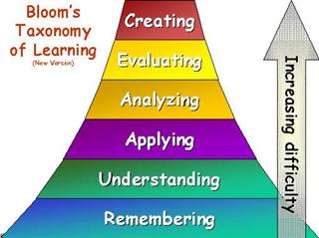

Creating: Build something new from diverse elements. Put parts together to form a whole, with the emphasis on creating a new meaning or structure.
Evaluating: Make judgments about the value of ideas or materials. Give opinions with reasons.
Analyzing: Separate material or concepts into component parts so the structure may be understood. Differentiate between fact and inference.
Applying: Use a concept in a new situation. Apply what was learned in the classroom in a new situation.
Understanding: Understand the meaning of something. Follow an instruction. Describe a problem.
Remembering: Recall previous learned information.

Which of these do teachers in Malawian primary schools mostly do?

Note: This is the revised taxonomy, developed by Lorin Anderson in the 1990s.
Image taken from: http://stoughirt.weebly.com/blooms-taxonomy.html

Session 11 – Challenges and Solutions - Resource 1
Problem Scenarios

1) Groupwork doesn’t work because there are too many learners
I can’t monitor the groupwork effectively. They can’t sit in circles because there is not enough space.
When I ask them to discuss something, the noise becomes too loud.

2) With all this participatory learning, I don’t know how I’m supposed to give them new knowledge
The learners enjoy working in groups, but often they can’t complete the task because they don’t have the required knowledge. I know I’m not allowed to lecture the learners. How can I give them that knowledge without my lesson becoming teacher-centred?

3) Groupwork doesn’t work because of the different abilities of the learners
The strong learners dominate the activities. They do the writing, solve the problems, think of the answers and the weaker ones just watch. Sometimes the weak ones just stare out the window.

4) I find it difficult to assess individual learners with too much groupwork
I used to do a lot of individual work. I could see how well each learner was doing, and I was able to evaluate my Success Criteria much better. Now it’s difficult because I don’t know who is getting the answer right in the group, and who is getting it wrong.

5) I’m following the lessons in the Teacher’s Guide… but my learners aren’t!
I now teach lessons exactly as described in the Teacher’s Guide for my standard. But sometimes the learners don’t seem to get the lesson. They find it too difficult or they take too long to do an activity. This means I can’t finish it in time. The next day I start the next lesson as instructed in the Teacher’s Guide, but my learners have already forgotten yesterday’s lesson.

6) I don’t have enough Pupil’s Books
I only have 7 copies of the Pupil’s Book for my P3 class of 103 learners. So instead of using it, I just copy the lesson onto the board and get the learners to copy it into their exercise books. This often takes 15 minutes, so we don’t have enough time for the lesson.

Session 11 – Challenges and Solutions - Resource 2
Advice for Problem Scenarios
1) Groupwork doesn’t work because there are too many learners
Although groupwork is useful, remember that it is not always necessary. You should balance it with individual work and pairwork (See Resource 3 for more on this). Individual work is necessary for learners to develop skills, especially whenever they are writing. After individual work you can let them check answers in pairs. If your class is so big that you can’t monitor effectively, train ‘group monitors’ to make sure that their group is doing the activity correctly, quietly and in the right way.

2) With all this participatory learning, I don’t know how I’m supposed to give them new knowledge
Try to ensure that there is new learning in every lesson. It’s OK to use teacher presentations, but if you do, remember to check understanding after each idea. You can also use texts in the Pupil’s Book that they read to learn something new. You can also use diagrams and drawings on the board or posters. It is usually good to do pairwork or groupwork after this, so that they can apply the new learning.

3) Groupwork doesn’t work because of the different abilities of the learners
In large classes, especially at standards 1-4, pairwork or groups of 3-4 is often more successful than large group work (5 or more). Smaller groups encourage more participation by each group member. You can also give roles to the learners in each small group, which helps you to ‘differentiate’ the learning. If the activity is difficult, the strongest learners can explain to the weaker ones. If it is easy, the strongest learners can ‘take a back seat’ and let the others try to solve it first. Alternatively, you can group weaker learners together and give them an easier task than the stronger learners. This enables you to include remedial learning in your lessons.

4) I find it difficult to assess individual learners with too much groupwork
Groupwork is an opportunity to use a greater variety of assessment methods. Here are some ideas:
- use peer assessment – learners can mark their partner’s work and report marks back to the teacher;
- group leaders can collect the marks and write them on a summary sheet;
- monitor groupwork carefully yourself to find out how well they are doing. This allows for formative assessment (assessment for learning);
- use target groups where you focus on just one group of learners each day. It’s a good idea to move this group closer to the front of the class. You can rotate the groups every day if you like.

5) I’m following the lessons in the Teacher’s Guide… but my learners aren’t!
Remember that your job is to teach the learners, not the book. Different classes will progress at different speeds, so if your learners need more time on an activity, give them that time. If they haven’t understood today’s lesson, revisit it tomorrow. If you do this, you may not complete the whole curriculum, but what you complete they will understand. Remember that the curriculum dictates the path, but the learners dictate the speed.

6) I don’t have enough Pupil’s Books
Being creative is the answer. Here are several ideas:
- Don’t copy the lesson onto the board while the learners are waiting. Copy it onto a poster before class. You can use the poster again next year.
- Select carefully what you will put on the board. Only get learners to copy the notes that they will need in future.
- At higher levels, you can even get the learners’ help in copying to the board. A learner with good handwriting can come and collect the book either before the lessons start or during a break, and copy it for you.
- With careful organisation up to 17 learners can all read from one book. 2 learners stand and support the book so that they can read it from the side. In front of them a row of 4 learners sit and look up, behind them a row of 5 learners sit and read and another row of 6 learners stand and read. This is fine for short reading activities up to 5 minutes. Using this method, 6 Pupil’s Books is enough for 100 learners.

Session 11 – Challenges and Solutions - Resource 3
Individual work, pairwork or groupwork?

Collaborative learning is only effective if you have a reason for your choice of interaction pattern. There should also be a variety of interaction patterns in each lesson to suit both intrapersonal learners (who learn effectively when they do activities and solve problems alone) and interpersonal learners (who learn more effectively when working with others). Here are some guidelines.

Interaction Pattern | Examples
1) Individual Work  Use individual work in the following situations:  - whenever each learner needs to practise a skill;  - whenever you want them to write or draw something that is personal to each learner;  - whenever each learner needs to think before communicating. | a) Learners are practising handwriting skills in Chichewa or English.  b) Learners are practising basic operations in mathematics, such as addition or multiplication exercises.  c) Learners are writing a short text about their family, or labelling a picture of their house.  d) Learners make notes on a discussion question before comparing their ideas with others.
2) Pairwork  Use pairwork in the following situations:  - whenever an exercise may be a little too difficult for some learners to do individually;  - whenever you want each learner to practise speaking skills;  - after individual work, they will benefit from checking in pairs before correction / feedback. | a) Learners are practising speaking skills in English, for example role playing a dialogue.  b) Learners are reading a difficult text to answer comprehension questions.  c) Learners are checking answers to an exercise before correction on the board.  d) Learners are comparing ideas during ‘think, pair, share’ (see below)
3) Groupwork  Use groupwork in the following situations:  - whenever learners are trying out a new skill for the first time;  - whenever the learners can learn from each other;  - whenever they need to discuss something, especially if critical thinking is required;  - whenever learners are working on a task towards a common goal;  - whenever learners need to get information from each other.  Avoid group of over 4 learners. If you have 5 or more in a group, the strongest learners may often dominate the activity. | a) Learners are brainstorming lists, ideas or possible solutions to a problem.  b) Learners are trying out a new basic operation in mathematics that may be difficult.  c) Some learners in the group are able to teach other learners in the group.  d) Learners are discussing a complex case study.  e) Learners are preparing a poster / presentation on something they have learned.  f) Learners are doing a survey activity on the members of their group.

Think, pair, share: From small to large groups
Think, pair, share can be used when you want the learners to think critically about something. First they think about their own answer, then they tell their partner, then they share either with their group or the class.

Triangular learning: From large to small groups
In mathematics, after doing a new operation as a whole class, get them to do one or two examples in small groups first. Then they can try a few more examples in pairs, and then they should be able to do the operation individually, which will enable you to assess achievement of your success criteria.

Session 12 – Implementation - Resource 1 – For PEAs / Teacher Trainers
Implementing Effective Child-centred Learning in Malawi
Work in groups. Choose a group secretary to take notes here:
In order to implement effective child-centred learning in our schools…
1) Who do we need to train next? Why?

2) What do we need to train them in?
i.e. What do they need to learn about effective child-centred learning? Choose both elements from this workshop and anything that weren’t in this workshop but you think they’d need.

3) What do they need to do with what they’ve learnt?
i.e. What would be the next stage of implementation?

4) What else needs to happen?

Session 12 – Implementation - Resource 2 – For Teachers
Implementing Effective Child-centred Learning in Malawi
Work in groups. Choose a group secretary to take notes here:
In order to implement effective child-centred learning in our schools…

1) What is the best way to begin?
i.e. Which classes should we start with? When should we start?

2) What help do we need from our PEA / Key Teacher / Mentors?

3) How can we help each other?

Session 12 – Implementation - Resource 3 – Poster Plan
Create a poster with the following format / table and complete the poster:

Group Name: _______________________________________

What we hope to do:
Action: | by (date):
What assistance we need:
We need: | from:
What results we will see (indicators of success):
We will see: | when:

Session 13 – Lesson Preparation for a Child-centred Lesson - Resource 1

Preparing a Child-centred Lesson

Your objectives for this session are:
- to create a child-centred lesson based on the curriculum and / or textbook for your designated subject and level
- to produce a complete written lesson plan
- to produce the resources you will need to teach the lesson
- to decide who will teach what (ensure the whole group is involved in teaching)
- to rehearse teaching

You have the whole of the afternoon to prepare. There will be facilitators for you to consult for advice if you need their assistance. You can draw upon any of the resources here, so think creatively! Remember that it takes much longer for a team of teacher-trainers to prepare a lesson than it does for one teacher. Working as an effective team this afternoon is just as important as teaching a good lesson tomorrow. The best way to do this is to create a skeleton lesson plan and divide into smaller groups to prepare for (and teach) different stages. You must be ready to teach tomorrow morning.

The lessons will be taught tomorrow morning as full-length 35-minute lessons to children at a local primary school. The lessons will be observed by facilitators. You will have up to 15 minutes before your lesson starts to prepare the room. Remember that you should think carefully about how you can make your lesson work in a traditional school classroom.

The groups, subjects and levels are as follows:

Group | Subject | Level

Session 13 – Lesson Preparation for a Child-centred Lesson - Resource 2 – Lesson Plan
CLASS:
DATE:
TIME:
LEARNING AREA:
LESSON:
SUCCESS CRITERIA:

TEACHING, LEARNING AND ASSESSMENT RESOURCES :

Teacher Activities | Learner Activities
Introduction

Developmental Steps

Developmental Steps (continued)

Conclusion

Lesson Evaluation

Session 16 – Self and Peer-evaluation of Lessons Resource 1
Lesson Evaluation Form

Before you discuss the lesson with your colleagues and facilitators, take some time to reflect personally on how the lesson went. Remember that today was an experiment, and the aim was to learn from both successes and errors. Try to be objective in your evaluation and don’t forget to praise yourselves for your successes.

- How well did the lesson meet its aims as specified in the success criteria? Provide reasons.

- How successful was the lesson design? Focus here on the lesson preparation and planning, and consider to what extent these contributed to achievement or non-achievement of aims.

- How well did the teaching resources work? Focus on whether they made learning easier for the learners, and whether the time spent creating them was justified by their usefulness.

- How well did you deliver the lesson? Focus on your teaching skills as a group (but feel free to praise colleagues for their strengths here). Did you adapt the lesson to the learners’ needs and level?

- How child-centred was the lesson? Reflect on how the methodology that you used helped each child to learn as naturally and enjoyably as possible. How involved was each child? How much did they enjoy it?

Session 17 – Personal Action Plans Resource 1
Last year, 67% of the children passed examinations. This year, over 75% have passed. I think we are not doing bad. Keep it up colleagues.

I feel I cannot manage to teach this topic. It is too diff. What
I I feel I cannot manage to teach this topic. It is too difficult for me. What Should I do then? I see. Let me ask Mrs. Phiri to help me

I cannot manage to teach this topic. It is too difficult. What should I do then? I think I will ask Mrs. Phiri to help me.

I have seen your work Mr. Mwale. You are doing a good job. You just need some touches here and there.
too difficult for me. What Should I do then? I see. Let me ask Mrs. Phiri to help me

Discussion Task

Look at statements A, B and C. What do they all have in common?


Session 17 – Personal Action Plans Resource 2
Evaluation
What is evaluation?
A simple definition of evaluation is: checking how well something has been done; whether it has been a success, a failure or something in between.

Which of the pictures on Resource 1 shows the following ways to evaluate our work?
- Self evaluation
- Peer evaluation and
- Objective evaluation

3 ways to evaluate your work
- Objective evaluation is when we use statistical evidence to evaluate something. For example a businesswoman can look at profits over the year, or how many new clients she has attracted over a year.
- Self-evaluation is where you look at your work yourself, and think about how well it is going or how well it has gone. It’s something we do naturally, but often we can do it better if we write it down, or simply tell it to somebody else.
- Peer-evaluation is where somebody else evaluates your work. This includes your boss, who may do a yearly appraisal, or a colleague who could observe your lesson and provide feedback.

Application
How do the following people evaluate their work? Think about the 3 categories you’ve looked at.
A teacher

A head teacher

A PEA

Session 17 – Personal Action Plans Resource 3
Individual Learning Plan

Personal Objective:
What would you like to improve in your own work over the next 12 months?
You can choose an area of content knowledge that you need to improve, a personal weakness, a strength that you feel you can improve further, or perhaps something you have neglected.

Reflection:
Why did you choose this objective? How has this affected your work over the last 12 months?
Try to describe it in detail. It may be a lack of knowledge that has caused problems, a fear of something new, a weakness that has led to mistakes. You can include a specific example.

Indicators:
How will you evaluate whether you have achieved this personal objective?
e.g. exam results for a teacher; pass rates for a pre-service teacher trainer; number of workshops completed for a PEA.

Objective evaluation:

Self-evaluation:
e.g. I will document successes and failures in this area in my diary; I will keep lesson plans and look back on them after 1 year; I will make a note of times when I wasn’t able to help others.

e.g. I’ll get a colleague to watch one of my lessons every 3 months for the next year; I’ll ask my boss to conduct an appraisal now and again in one year; I’ll give out feedback forms after workshops.

Peer evaluation:

Details:
When will you evaluate it? _________________________
Who will you choose as your mentor? _________________________
Mentor endorsement signature: _________________________ Date: ________________

Session 18 – Workshop Evaluation - Resource 1
Workshop Evaluation Form
Aim: To improve the quality of teaching and learning in Malawian primary classrooms through strengthening the capacity of the Ministry of Education, teacher training colleges, the curriculum development department and selected primary schools to promote child-centred learning with the support and assistance of UNICEF Malawi and VSO Malawi.

Objectives: By the end of the workshop participants will…
- have a sound understanding of the concepts and practices of child-centred, interactive methodology in teaching and learning processes
- have increased awareness of active learning and problem solving opportunities
- be able to use a simple planning system to support a child friendly curriculum
- be able to design and make a range of high quality, low cost cross-curricular classroom materials and teaching aids to support child-- centred learning
- have prepared, taught and evaluated a child-friendly lesson (in a Malawian primary school)
- have begun planning to implement a child-centred approach to learning in Malawian primary schools

Please provide feedback on the following areas, using the following scale:
4 – Very good 3 – Good 2 – Satisfactory 1 – Unsatisfactory
Add any comments here:
____________________________________________
____________________________________________
____________________________________________
____________________________________________
____________________________________________
____________________________________________
____________________________________________
____________________________________________
____________________________________________
____________________________________________
____________________________________________
____________________________________________

General workshop evaluation:
Evaluation of relevance for your work:
Facilitators / Trainers:
Organisation and timetable:
The workshop environment:
Other: _______________________
Here you can choose to evaluate something
that you would like to comment on personally.

Please sum up the workshop for you in one sentence:

How well did the workshop meet your expectations?

What did you find useful in the training?

What didn’t you find useful in the training?

What will you change in your work as a result of this workshop?

What would you have liked that was not dealt with in the training?

How was the workload? Too intense, OK, or not enough?

What recommendations would you make for…
a) a follow-up course for you?

b) a similar course for your colleagues?

Are you a teacher?  teacher trainer?  other?  (tick just one box)
Thank you. If you would like to provide your name, write it here: __________________________________

