Remera Sector Ministry of Education - Pedagogic Training Workshops

Wonderful Flashcards

What is a flashcard?
A flashcard is a piece of paper or card with a letter, a number, a word or a picture written on it. Sometimes there is something written on the other side (e.g. translation, answer, name, etc.)

Why are flashcards useful?
Flashcards are useful because we can use them many times. They provide variety and interest for children. We can use them for literacy practice, both English and Kinyarwanda (letters at P1, igihekane and words at P2-P3, etc.), for maths literacy (learning numbers and symbols +, x, =, etc.), for memorising vocabulary and for encouraging children to be creative. Each teacher can keep his / her own set, and can add to them all the time. You can keep your flash cards in a box, divided into different categories (letters, pictures, nouns, verbs, etc.)

How do I make flashcards?

Basic Flashcards
You just need paper and a marker pen. If you need a marker pen, ask your head teacher. Even if you don’t have a marker pen, you can make them with a bic (see picture below), or with coloured chalk; blue and purple work best.

Hanging Flashcards
These are very good when you want to combine flashcards in an order (e.g. maths sums, or sentences in English). You need larger pieces of paper / card, which are folded. You also need a piece of string that you can hang beneath or across the chalk board (see picture below). You can write on both sides of the card and flip them over.

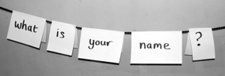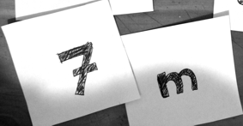
hanging flashcards ‘bic’ flashcards

What activities can I do with flashcards?

Basic Literacy
1) Show & Elicit (P1-4) Show the flashcard and elicit the word / number / name / translation
2) Point at (P1-3) Flashcards are held up by students in different parts of the room. Tell the other students to point at one card.
3) Give me (P1-4) Put many flashcards on the floor. Tell one student to bring you one card.

Sequence Formation
1) Make a sentence (P2-6) Stand several students in a line at the front of the class, each with one flashcard. The others must tell them to stand in the correct order.
2) Creative maths (P1-3) Display number and symbol flashcards. Ask students: ‘Who can make a sum?’

Vocabulary learning
1) Translate (P1-6) Show English, elicit Kinyarwanda (on the back) or vice versa.
2) Vocabulary Box (P1-6) Keep the class flashcards in a box. Each day, one student can come to the front to test the others on the pronunciation / meaning / translation of the cards.

These are simple ideas. There are many more ways to use flashcards.

What will you use flashcards for?

